

**ARTI407 – Image Processing**

**STUDENT PROCEDURAL MANUAL Lab 2**

**2019 - 2020**

**College of Computer Science and Information Technology**

**كلية علوم الحاسب وتقنية المعلومات**

**DEPARTMENT OF COMPUTER SCIENCE**

|  |  |  |
| --- | --- | --- |
| **Session Topic/Title** | **Session No.** | **Session Duration (Minutes)** |
| Basics Operations on Image | 2 | 100 |

|  |  |
| --- | --- |
| 1. **Session Outcomes** |  |

**Outcome#1:** Explain how digital images are represented and manipulated in a computer.

|  |  |
| --- | --- |
| 1. **Tool(s)/Software** | *.* |

* Python 3
* Anaconda
* IDE for Python: Jupyter, Spyder.
* Libraries: Pillow, OpenCV, SciKit-Image.

|  |  |
| --- | --- |
| 1. **procedural steps (Tasks)** |  |

**Step#1:Install Pillow Library:**

To read an image from storage, we will use pillow library. You can install pillow library using the

* pip install pillow

**Step#2:Install OpenCV Library:**

The Python come up with pillow library to deal with the images for processing. There’s one more library “OpenCV v4” is also known and is used by the various languages like C++, Java etc. for image processing. To install OpenCV, again use the pip command.

* pip install OpenCV

**Step#3:Install SciKit Library:**

The SciKit-Image library using Python is popular. Scikit-image is an image processing Python package that works with numpy arrays which is a collection of algorithms for image processing. Let’s discusses how to deal with images into set of information and its some application in real world.

**Note:** Before installing scikit-image, ensure that NumPy and SciPy are pre-installed. Now, the easiest way to install scikit-image is using pip:

* pip install -U scikit-image

***Issues/error generated during installation:***

Some time you might got error while installing via pip. There might be different reasons for the errors, but in most cases, we can reduce errors, if we start Spyder/Python with admin user, check network allow us to access the target pages (from where the library is download) and availability of Microsoft Visual C++ v.14 on your system.

**Step#4: Read an image**

from PIL import Image

import sys

try:

img = Image.open("bitmap2.jpg")

except IOError:

print("Unable to load image")

sys.exit(1)

img.show()

The example prints basic information about the image with Pillow.

print("Format: ", img.format, "\nSize: ", img.size, "\nMode: ", img.mode)

**Step#5: Perform some modifications on an image**

1. **Rotate Image with some degree specified**

rot = img.rotate(180)

rot.show()

1. **Rotate Image by using Transpose function**

rot3 = img.transpose(Image.FLIP_LEFT_RIGHT)

rot2 = img.transpose(Image.ROTATE_270)

rot2.show()

1. **Crop Image**

crop = img.crop((100,100,150,150))

crop.show()

1. **Copy a subrectangle from an image**

box = (100, 100, 400, 400)

region = im.crop(box)

region.show()

**Task#1: Read the image Mario and display it like this.**

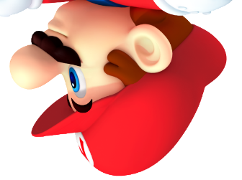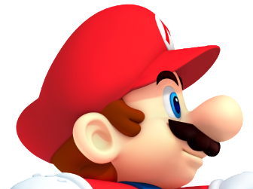

**Task#2: Convert the same image into 2nd display image.**

**Task#3: Convert the Mario image into Gray Scale.**

**Task#4: Apply the Lab02-b.py to read the data from excel sheet and display them. (already provided).**

What you need to do, change the values of the array (i.e. check) with values within range of 0-254 and then display it and record your answer.

|  |  |
| --- | --- |
| 1. **Assessment** |  |

The student will be asked to accomplish the four tasks within the lab time.

|  |  |
| --- | --- |
| 1. **Resources** |  |

[Pillow Library Documentation](https://pillow.readthedocs.io/en/stable/handbook/tutorial.html)

|  |  |
| --- | --- |
| **Submission** |  |

The students need to prepare the report in a PDF format and submit via Blackboard with the following details.

* Assignment #:
* Student_ID:
* Student_Name:
* Class Name:

Task code / clear screen shot of the code.

Output: Screen shot